Homothety

Definition
# Source: AI Source: Provided by: [Data Path: Persons Table -> ID Column: 1, Name_En Column: Motasem Essam] -> From: [ChatGPT] on [7/25/2026]
A Homothety is a geometric transformation that maps a figure to another figure by scaling every point relative to a fixed center called the center of homothety.
Every point and its image lie on the same line through the center, and their distances from the center are multiplied by the same constant scale factor $k$.
$$\boxed{OP^{'}=k OP}$$
where:
- $O$= center of homothety
- $P$= original point
- $P^{'}$= image of $P$
- $k$= scale factor
Homothety is therefore a particular type of similarity transformation.
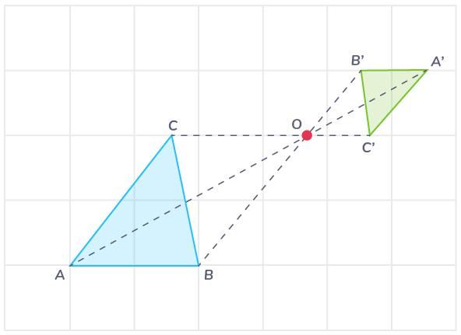
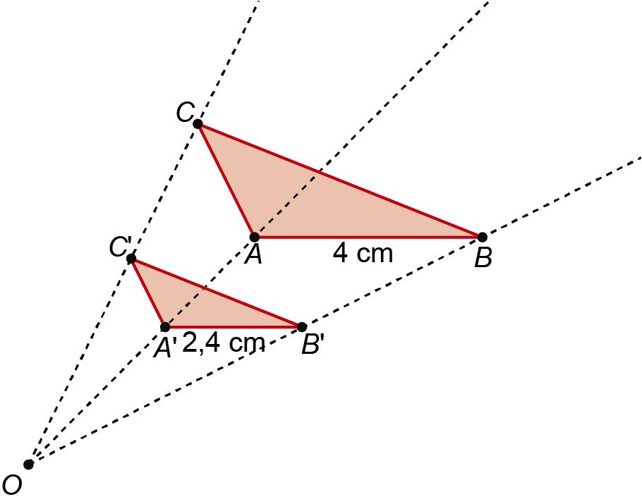
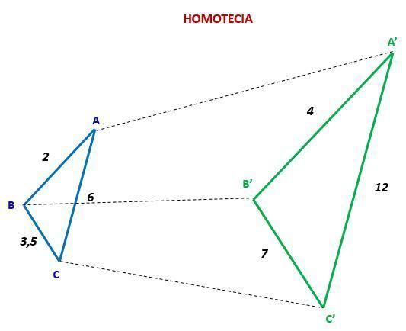
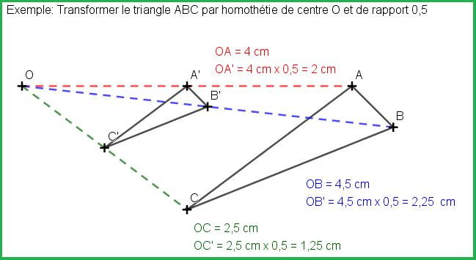
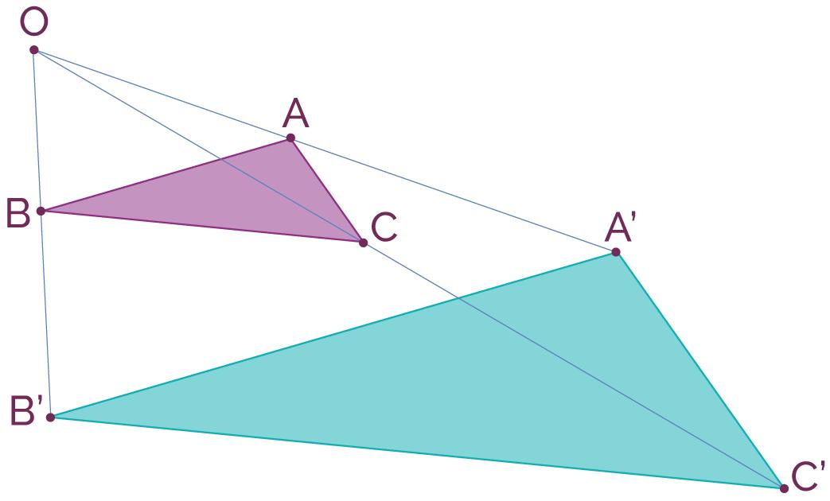

Fundamental Concept
# Source: AI Source: Provided by: [Data Path: Persons Table -> ID Column: 1, Name_En Column: Motasem Essam] -> From: [ChatGPT] on [7/25/2026]
The defining idea is:
All points are scaled from one fixed center by the same factor.
For a point $P$:
$$P→P^{'}$$
with:
$$O,P,P^{'}$$
lying on the same line.
The distance from $O$changes according to:
$$\boxed{OP^{'}=∣k∣OP}$$
The directed-vector form is:
$$\boxed{\vec{OP^{'}}=k\vec{OP}}$$

Basic Structure
# Source: AI Source: Provided by: [Data Path: Persons Table -> ID Column: 1, Name_En Column: Motasem Essam] -> From: [ChatGPT] on [7/25/2026]
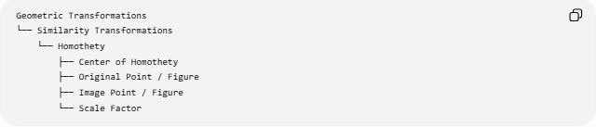
Geometric Transformations
└── Similarity Transformations
└── Homothety
├── Center of Homothety
├── Original Point / Figure
├── Image Point / Figure
└── Scale Factor
A homothety has three essential elements:
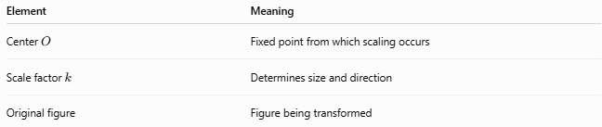
Element | Meaning
Center $O$ | Fixed point from which scaling occurs
Scale factor $k$ | Determines size and direction
Original figure | Figure being transformed

Mathematical Representation
# Source: AI Source: Provided by: [Data Path: Persons Table -> ID Column: 1, Name_En Column: Motasem Essam] -> From: [ChatGPT] on [7/25/2026]
For a homothety with center $O$:
$$\boxed{H_{O,k}\left(P\right)=O+k\left(P-O\right)}$$
In vector notation:
$$\boxed{\vec{OP^{'}}=k\vec{OP}}$$
This is the fundamental equation of homothety.

Coordinate Form
# Source: AI Source: Provided by: [Data Path: Persons Table -> ID Column: 1, Name_En Column: Motasem Essam] -> From: [ChatGPT] on [7/25/2026]
Suppose the center of homothety is:
$$O=\left(h , k\right)$$
and a point is:
$$P=\left(x , y\right)$$
with scale factor $s$.
Then:
$$\boxed{x^{'}=h+s\left(x-h\right)} \\ \boxed{y^{'}=k+s\left(y-k\right)}$$
Therefore:
$$\boxed{P^{'}=\left(h , +s\left(x-h\right)k+s\left(y-k\right)\right)}$$

Homothety Centered at the Origin
# Source: AI Source: Provided by: [Data Path: Persons Table -> ID Column: 1, Name_En Column: Motasem Essam] -> From: [ChatGPT] on [7/25/2026]
If:
$$O=\left(0 , 0\right)$$
then the equations simplify to:
$$\boxed{x^{'}=kx} \\ \boxed{y^{'}=ky}$$
or:
$$\boxed{\left(x , y\right)→\left(k , xky\right)}$$
This is the standard coordinate representation of a dilation centered at the origin.

Scale Factor
# Source: AI Source: Provided by: [Data Path: Persons Table -> ID Column: 1, Name_En Column: Motasem Essam] -> From: [ChatGPT] on [7/25/2026]
The scale factor $k$determines the relationship between the original and image figures.
$$\boxed{k=\frac{OP^{'}}{OP}}$$
when using ordinary positive distances.
Using directed vectors:
$$\boxed{\vec{OP^{'}}=k\vec{OP}}$$

Types of Homothety
# Source: AI Source: Provided by: [Data Path: Persons Table -> ID Column: 1, Name_En Column: Motasem Essam] -> From: [ChatGPT] on [7/25/2026]
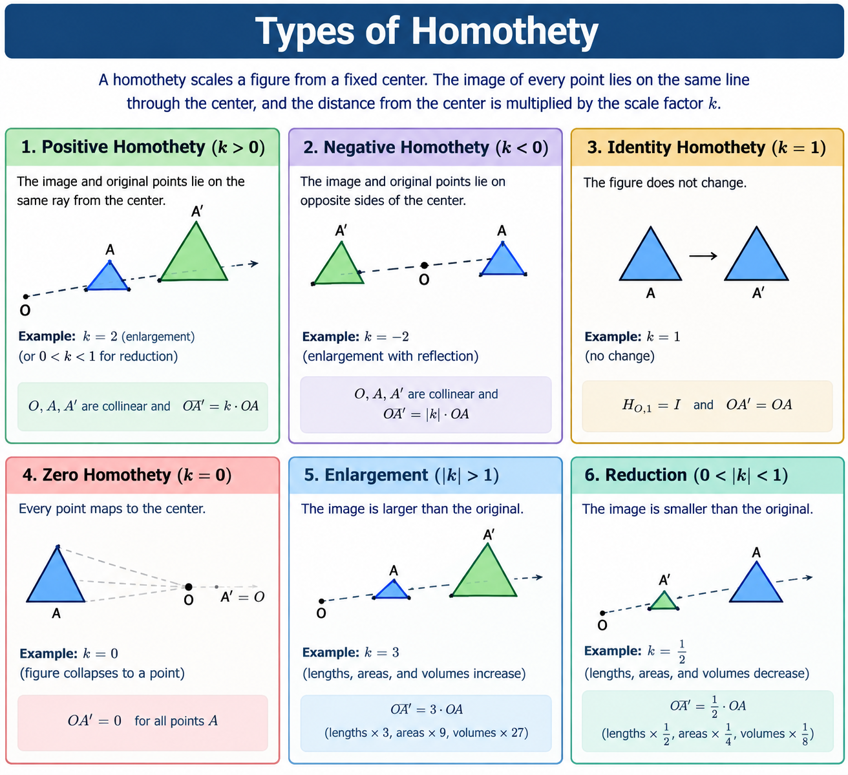

1-Positive Homothety
# Source: AI Source: Provided by: [Data Path: Persons Table -> ID Column: 1, Name_En Column: Motasem Essam] -> From: [ChatGPT] on [7/25/2026]
If:
$$\boxed{k>0}$$
then $P$and $P^{'}$lie on the same ray starting from $O$.
O ───── P ───────── P'
For:
$$k>1$$
the figure is enlarged.
For:
$$0<k<1$$
the figure is reduced.

2-Negative Homothety
# Source: AI Source: Provided by: [Data Path: Persons Table -> ID Column: 1, Name_En Column: Motasem Essam] -> From: [ChatGPT] on [7/25/2026]
If:
$$\boxed{k<0}$$
then $P$and $P^{'}$lie on opposite sides of $O$.
P' ───────── O ───────── P
The figure is scaled and positioned on the opposite side of the center.

3-Identity Homothety
# Source: AI Source: Provided by: [Data Path: Persons Table -> ID Column: 1, Name_En Column: Motasem Essam] -> From: [ChatGPT] on [7/25/2026]
If:
$$\boxed{k=1}$$
then:
$$P^{'}=P$$
and the figure does not change.
Thus:
$$\boxed{H_{O,1}=I}$$
where $I$is the identity transformation.

4-Zero Homothety
# Source: AI Source: Provided by: [Data Path: Persons Table -> ID Column: 1, Name_En Column: Motasem Essam] -> From: [ChatGPT] on [7/25/2026]
If:
$$\boxed{k=0}$$
then every point maps to the center:
$$\boxed{P^{'}=O}$$
The entire figure collapses to a single point.
In some geometric contexts, $k=0$is excluded when homothety is required to map a figure to a similar figure of nonzero size.

Enlargement and Reduction

Enlargement
# Source: AI Source: Provided by: [Data Path: Persons Table -> ID Column: 1, Name_En Column: Motasem Essam] -> From: [ChatGPT] on [7/25/2026]
If:
$$\boxed{∣k∣>1}$$
the image is larger than the original.

Reduction
# Source: AI Source: Provided by: [Data Path: Persons Table -> ID Column: 1, Name_En Column: Motasem Essam] -> From: [ChatGPT] on [7/25/2026]
If:
$$\boxed{0<∣k∣<1}$$
the image is smaller.

Same Size
# Source: AI Source: Provided by: [Data Path: Persons Table -> ID Column: 1, Name_En Column: Motasem Essam] -> From: [ChatGPT] on [7/25/2026]
If:
$$\boxed{∣k∣=1}$$
the size is unchanged.
For $k=1$, the transformation is the identity.
For $k=-1$, the transformation is a ${180}^{∘}$rotation about $O$.

Effect on Lengths
# Source: AI Source: Provided by: [Data Path: Persons Table -> ID Column: 1, Name_En Column: Motasem Essam] -> From: [ChatGPT] on [7/25/2026]
Every length is multiplied by:
$$\boxed{∣k∣}$$
Therefore:
$$\boxed{L^{'}=∣k∣L}$$
For example, if:
$$L=5\text{ cm}$$
and:
$$k=3$$
then:
$$L^{'}=15\text{ cm}$$

Effect on Area
# Source: AI Source: Provided by: [Data Path: Persons Table -> ID Column: 1, Name_En Column: Motasem Essam] -> From: [ChatGPT] on [7/25/2026]
Area is multiplied by the square of the absolute scale factor:
$$\boxed{A^{'}=k^{2}A}$$
Since:
$$k^{2}=∣k∣^{2}$$
the sign of $k$does not affect area.
For:
$$k=2 \\ A^{'}=4A$$

Effect on Volume
# Source: AI Source: Provided by: [Data Path: Persons Table -> ID Column: 1, Name_En Column: Motasem Essam] -> From: [ChatGPT] on [7/25/2026]
For three-dimensional homothety:
$$\boxed{V^{'}=∣k∣^{3}V}$$
For example:
$$k=2$$
gives:
$$V^{'}=8V$$

Effect on Angles
# Source: AI Source: Provided by: [Data Path: Persons Table -> ID Column: 1, Name_En Column: Motasem Essam] -> From: [ChatGPT] on [7/25/2026]
Homothety preserves angles:
$$\boxed{m∠A^{'}=m∠A}$$
Therefore, a figure and its homothetic image are similar.

Collinearity
# Source: AI Source: Provided by: [Data Path: Persons Table -> ID Column: 1, Name_En Column: Motasem Essam] -> From: [ChatGPT] on [7/25/2026]
Homothety preserves collinearity.
If points $A,B,C$lie on one line, their images:
$$A^{'},B^{'},C^{'}$$
also lie on one line.
Moreover, lines not passing through the center generally map to parallel lines.

Parallel Lines
# Source: AI Source: Provided by: [Data Path: Persons Table -> ID Column: 1, Name_En Column: Motasem Essam] -> From: [ChatGPT] on [7/25/2026]
Suppose a line $l$does not pass through the center $O$.
Under a homothety, its image $l^{'}$is parallel to $l$:
$$\boxed{l^{'}∥l}$$
If the line passes through $O$, it maps onto itself.

Example
# Source: AI Source: Provided by: [Data Path: Persons Table -> ID Column: 1, Name_En Column: Motasem Essam] -> From: [ChatGPT] on [7/25/2026]
Let:
$$O=\left(0 , 0\right)$$
and:
$$P=\left(2 , 3\right)$$
Apply a homothety with:
$$k=2$$
Then:
$$P^{'}=\left(2 , \left(2\right)2\left(3\right)\right)$$
so:
$$\boxed{P^{'}=\left(4 , 6\right)}$$
Notice:
$$\vec{OP^{'}}=2\vec{OP}$$
and $O,P,P^{'}$are collinear.

Example with a Non-Origin Center
# Source: AI Source: Provided by: [Data Path: Persons Table -> ID Column: 1, Name_En Column: Motasem Essam] -> From: [ChatGPT] on [7/25/2026]
Let:
$$O=\left(2 , 1\right)$$
and:
$$P=\left(5 , 4\right)$$
with:
$$k=2$$
Using:
$$x^{'}=h+k\left(x-h\right) \\ y^{'}=k_{0}+k\left(y-k_{0}\right)$$
where the center coordinates are $h=2$, $k_{0}=1$:
$$x^{'}=2+2\left(5-2\right)=8 \\ y^{'}=1+2\left(4-1\right)=7$$
Therefore:
$$\boxed{P^{'}=\left(8 , 7\right)}$$

Homothety of a Triangle
# Source: AI Source: Provided by: [Data Path: Persons Table -> ID Column: 1, Name_En Column: Motasem Essam] -> From: [ChatGPT] on [7/25/2026]
Suppose:
$$△ABC$$
is transformed into:
$$△A^{'}B^{'}C^{'}$$
by a homothety centered at $O$.
Then:
$$O,A,A^{'} \\ O,B,B^{'} \\ O,C,C^{'}$$
are each collinear.
The corresponding side lengths satisfy:
$$\boxed{\frac{A^{'}B^{'}}{AB}=\frac{B^{'}C^{'}}{BC}=\frac{C^{'}A^{'}}{CA}=∣k∣}$$
Therefore:
$$\boxed{△ABC∼△A^{'}B^{'}C^{'}}$$

Important Property of the Center
# Source: AI Source: Provided by: [Data Path: Persons Table -> ID Column: 1, Name_En Column: Motasem Essam] -> From: [ChatGPT] on [7/25/2026]
The center $O$is fixed:
$$\boxed{H_{O,k}\left(O\right)=O}$$
For $k≠1$, it is the unique fixed point of the homothety in the plane.
This distinguishes homothety from ordinary translation.

Homothety vs Similarity Transformation
# Source: AI Source: Provided by: [Data Path: Persons Table -> ID Column: 1, Name_En Column: Motasem Essam] -> From: [ChatGPT] on [7/25/2026]
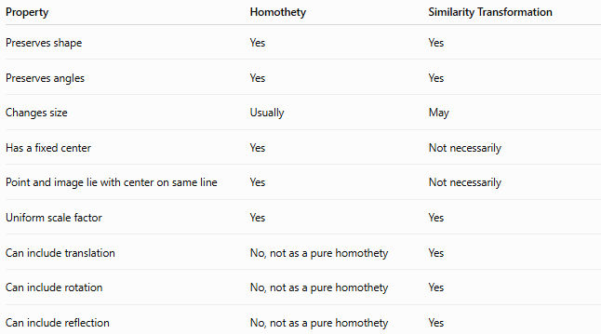
Property | Homothety | Similarity Transformation
Preserves shape | Yes | Yes
Preserves angles | Yes | Yes
Changes size | Usually | May
Has a fixed center | Yes | Not necessarily
Point and image lie with center on same line | Yes | Not necessarily
Uniform scale factor | Yes | Yes
Can include translation | No, not as a pure homothety | Yes
Can include rotation | No, not as a pure homothety | Yes
Can include reflection | No, not as a pure homothety | Yes
Thus, homothety is a more specific transformation than a general similarity transformation.

Homothety vs Dilation
# Source: AI Source: Provided by: [Data Path: Persons Table -> ID Column: 1, Name_En Column: Motasem Essam] -> From: [ChatGPT] on [7/25/2026]
In many modern geometry and transformation contexts, homothety and dilation are used very similarly.
The important geometric description is:
$$\boxed{\text{Fixed Center}+\text{Uniform Scaling}}$$
However, terminology can vary by textbook:
- Dilation is commonly used in coordinate and school geometry.
- Homothety is common in classical Euclidean geometry and emphasizes the center and the collinearity property.

Homothety vs Congruence
# Source: AI Source: Provided by: [Data Path: Persons Table -> ID Column: 1, Name_En Column: Motasem Essam] -> From: [ChatGPT] on [7/25/2026]
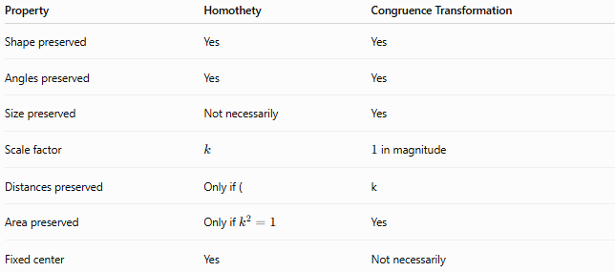
Property | Homothety | Congruence Transformation
Shape preserved | Yes | Yes
Angles preserved | Yes | Yes
Size preserved | Not necessarily | Yes
Scale factor | $$k$$ | $1$in magnitude
Distances preserved | Only if ( | k
Area preserved | Only if $k^{2}=1$ | Yes
Fixed center | Yes | Not necessarily
For a nontrivial homothety:
$$∣k∣≠1$$
the figure changes size and therefore is not a congruence transformation.

Composition of Homotheties
# Source: AI Source: Provided by: [Data Path: Persons Table -> ID Column: 1, Name_En Column: Motasem Essam] -> From: [ChatGPT] on [7/25/2026]
Consider two homotheties with the same center $O$:
$$H_{O,k_{1}}$$
followed by:
$$H_{O,k_{2}}$$
The resulting scale factor is:
$$\boxed{k=k_{1}k_{2}}$$
Therefore:
$$\boxed{H_{O,k_{2}}∘H_{O,k_{1}}=H_{O,k_{1}k_{2}}}$$
Example:
$$k_{1}=2, k_{2}=3$$
Then:
$$k=6$$
So the combined transformation scales the figure by $6$.

Classification
# Source: AI Source: Provided by: [Data Path: Persons Table -> ID Column: 1, Name_En Column: Motasem Essam] -> From: [ChatGPT] on [7/25/2026]
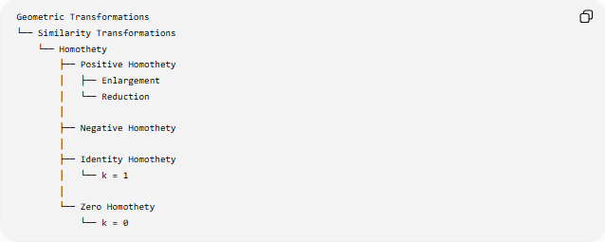
Geometric Transformations
└── Similarity Transformations
└── Homothety
├── Positive Homothety
│ ├── Enlargement
│ └── Reduction
│
├── Negative Homothety
│
├── Identity Homothety
│ └── k = 1
│
└── Zero Homothety
└── k = 0
A more precise classification by scale factor is:
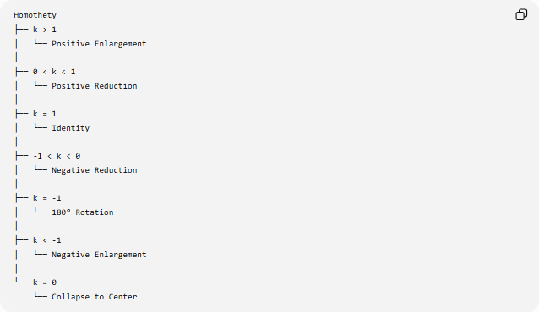
Homothety
├── k > 1
│ └── Positive Enlargement
│
├── 0 < k < 1
│ └── Positive Reduction
│
├── k = 1
│ └── Identity
│
├── -1 < k < 0
│ └── Negative Reduction
│
├── k = -1
│ └── 180° Rotation
│
├── k < -1
│ └── Negative Enlargement
│
└── k = 0
└── Collapse to Center

Key Points
# Source: AI Source: Provided by: [Data Path: Persons Table -> ID Column: 1, Name_En Column: Motasem Essam] -> From: [ChatGPT] on [7/25/2026]
- Homothety is a transformation based on scaling from a fixed center.
- Every point and its image lie on a line through the center.
- The defining relation is:
$$\boxed{\vec{OP^{'}}=k\vec{OP}}$$
- Lengths scale by:
$$\boxed{∣k∣}$$
- Areas scale by:
$$\boxed{k^{2}}$$
- Volumes scale by:
$$\boxed{∣k∣^{3}}$$
- Angles are preserved.
- $k>0$: original and image points are on the same ray from the center.
- $k<0$: they are on opposite sides of the center.
- $k=1$: identity transformation.
- $k=-1$: ${180}^{∘}$rotation about the center.
- Homothety is a particular type of similarity transformation.

Conclusion
# Source: AI Source: Provided by: [Data Path: Persons Table -> ID Column: 1, Name_En Column: Motasem Essam] -> From: [ChatGPT] on [7/25/2026]
A Homothety is a similarity transformation in which every point is scaled relative to a fixed center of homothety by the same scale factor:
$$\boxed{H_{O,k}\left(P\right)=O+k\left(P-O\right)}$$
It preserves shape, angles, collinearity, and proportional relationships, while changing lengths by $∣k∣$, areas by $k^{2}$, and volumes by $∣k∣^{3}$.
The most important geometric property is:
$$\boxed{O, P, P^{'}\text{ are collinear}}$$
together with:
$$\boxed{\vec{OP^{'}}=k\vec{OP}}$$
Thus, homothety is a centered form of similarity transformation based on uniform scaling.

